**Internship Report**

(Project Work)

**On**

**VisionVoice AI**

*Submitted to*

**JAWAHARLAL NEHRU TECHNOLOGICAL UNIVERSITY ANANTAPUR, ANANTHAPURAMU**

*In Partial Fulfillment of the Requirements for the Award of the Degree of*

**BACHELOR OF TECHNOLOGY**

**In**

**COMPUTER SCIENCE AND TECHNOLOGY**

**Submitted By**

**C Bramhendra – 23691A2823**

**Under the Guidance of**

**Mr. P. Lakshmi Ramana**

**Asst. Professor**

**Department of Computer Science and Technology**



**MADANAPALLE INSTITUTE OF TECHNOLOGY & SCIENCE**

**(UGC – AUTONOMOUS)**

**(Affiliated to JNTUA, Ananthapuramu)**

**Accredited by NBA, Approved by AICTE, New Delhi)**

**AN ISO 21001:2018 Certified Institution**

**P. B. No: 14, Angallu, Madanapalle, Annamayya – 517325**

**MADANAPALLE INSTITUTE OF TECHNOLOGY & SCIENCE**

(UGC-AUTONOMOUS INSTITUTION)

Affiliated to JNTUA, Ananthapuramu & Approved by AICTE, New Delhi

NAAC Accredited with A+ Grade

NBA Accredited -B.Tech. (CIVIL, CSE, CST, ECE, EEE, MECH) MBA&MCA

**DEPARTMENT OF COMPUTER SCIENCE AND TECHNOLOGY**

**BONAFIDE CERTIFICATE**

This is to certify that the **SUMMER INTERNSHIP-1 (23CST701)** entitled **“VisionVoice AI”** is a bonafide work carried out by

**C Bramhendra – 23691A2823**

Submitted in partial fulfillment of the requirements for the award of degree **Bachelor of Technology** in the stream of **Computer Science and Technology** in **Madanapalle Institute of Technology & Science, Madanapalle**, affiliated to **Jawaharlal Nehru Technological University Anantapur, Ananthapuramu** during the academic year 2025-2026.

**Guide** **Internship Coordinator/CST**

**Mr. P. Lakshmi Ramana Mr. V. Naveen**

**Assistant Professor Assistant Professor**

**Department of CST Department of CST**

**Head of the Department**

**Dr. K. Dinesh**

**Associate Professor and Head**

**Department of CST**

ii

**INTERNSHIP CERTIFICATE**

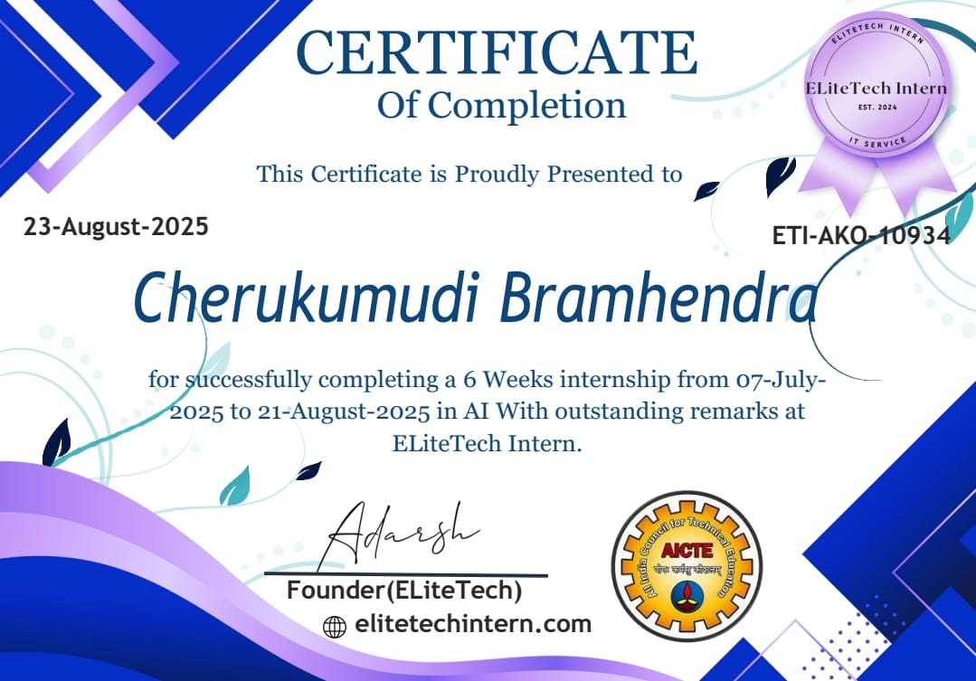

iii

**DECLARATION**

I hereby declare that results embodied in this **SUMMER INTERNSHIP- 1(23CST701)**

“**VisionVoice-AI**” by me under the guidance of **Mr. P. Lakshmi Ramana, Assistant Professor, Dept. of CST** in partial fulfillment of the award of **Bachelor of Technology** in **Computer Science and Technology** from **Jawaharlal Nehru Technological University Anantapur, Ananthapuramu** and I have not submitted the same to any other University/institute for award of any other degree.

**Date : 18/11/2025**

**Place : Madanapalle**

**PROJECT MEMBER**

**C Bramhendra (23691A2823)**

I certify that above statement made by the student is correct to the best of my knowledge.

**Date : 17/11/2025**

**Guide**

**Mr. P. Lakshmi Ramana**

**Assistant Professor**

**Department of CST**

iv

**TABLE OF CONTENTS**

|  |  |  |
| --- | --- | --- |
| **S.NO** | **TOPIC** | **PAGE NO.** |
| **1.** | **INTRODUCTION** | **1** |
|  | 1.1 About Industry or Organization Details | 2 |
|  | 1.2 My Personal Benefits | 2 |
|  | 1.3 Objective of the Project | 2 |
|  | 1.4 Limitations of Project | 3 |
| **2.** | **SYSTEM ANALYSIS** | **4** |
|  | 2.1 Introduction | 4 |
|  | 2.2 Existing System | 4 |
|  | 2.3 Disadvantages of Existing System | 5 |
|  | 2.4 Proposed System | 5 |
| **3.** | **SYSTEM SPECIFICATION** | **7** |
|  | 3.1 Hardware Requirement Specification | 7 |
|  | 3.2 Software Requirement Specification | 8 |
| **4.** | **SYSTEM DESIGN** | **10** |
|  | 4.1 System Architecture | 11 |
|  | 4.2 Modules Flow diagrams | 13 |
| **5.** | **IMPLEMENTATION AND RESULTS** | **15** |
|  | 5.1 Introduction | 15 |
|  | 5.2 Implementation of key functions | 16 |
|  | 5.3 Method of Implementation (CODING) | 17 |
|  | 5.4 Output Screens and Result Analysis | 18 |
| **6.** | **TESTING AND VALIDATION** | **25** |
|  | 6.1 Introduction | 25 |
|  | 6.2 Design of Test cases and Scenarios | 26 |
|  | 6.3 Validation | 28 |
|  | 6.4 Conclusion | 29 |
| **7.** | **CONCLUSION** | **31** |
|  | 7.1 Conclusion | 31 |
|  | **REFERENCES** | **34** |

v

**ABSTRACT**

The VisionVoice AI Assistant is an intelligent, multi-modal system that integrates Computer Vision (CV) and Natural Language Processing (NLP) to enhance user productivity through real-time focus monitoring and voice-driven automation. In a world where digital distractions continue to increase, the need for an assistant that not only responds to voice commands but also understands user presence and attention has become essential. VisionVoice addresses this need by combining face detection, focus tracking, and voice interaction into a single unified Python-based platform.

The system employs OpenCV’s Haar Cascade classifier for continuous face detection and attention analysis. It monitors the user’s presence, identifies focus lapses, calculates unfocused durations, and provides proactive audio-visual feedback to bring the user back on task. Parallelly, the integrated voice assistant—powered by SpeechRecognition, pyttsx3, and API services—supports a wide range of functionalities including weather updates, web search, jokes, fun facts, Wikipedia summaries, and YouTube playback. Through threaded concurrency, VisionVoice ensures simultaneous execution of voice listening and video processing without interrupting real-time performance.

The project follows a modular, event-driven design, enabling scalability and ease of maintenance. Each module (vision, voice, focus tracking, and system launcher) operates independently yet communicates seamlessly with the core assistant engine. To improve user experience, the system provides live on-screen indicators such as focus state, lapse counter, and thumbnail previews of the detected face.

By merging AI-driven computer vision with interactive voice control, VisionVoice showcases how hybrid systems can support productivity enhancement, e-learning engagement, proctoring assistance, and personal task automation. The project demonstrates the practical potential of combining CV and NLP to create smarter and more responsive AI applications that adapt to user behavior in real time.

vi

**List of Figures**

| **S. No** | **Figure No.** | **Name of the Figure** | **Page No.** |
| --- | --- | --- | --- |
| 1 | 4.1.1 | System Architecture of VisionVoice AI Assistant | 11 |
| 2 | 4.2.1 | Workflow Diagram of Voice + Vision Integration | 12 |
| 3 | 4.2.2 | Processing Model Architecture | 13 |
| 4 | 5.3.1 | Importing Libraries & Initializing CV + TTS + STT Modules | 18 |
| 5 | 5.3.2 | Smart Assistant Application | 18 |
| 6 | 5.3.3 | Face Detection Implementation | 19 |
| 7 | 5.3.4 | Voice Assistant Implementation | 20 |
| 8 | 5.3.5 | Smart Assistant Integration | 20 |
| 9 | 5.4.1 | Real-Time Face Detection Screen | 22 |
| 10 | 5.4.2 | **Voice Assistant Responses** | 22 |
| 11 | 5.4.3 | Smart Assistant Combined View | 23 |

vii

**LIST OF ABBREVIATIONS**

| **Abbreviation** | **Full Form** |
| --- | --- |
| AI | Artificial Intelligence |
| API | Application Programming Interface |
| CV | Computer Vision |
| FPS | Frames Per Second |
| GUI | Graphical User Interface |
| Haar Cascade | Haar Feature-Based Cascade Classifier |
| NLP | Natural Language Processing |
| STT | Speech-to-Text |
| TTS | Text-to-Speech |
| UI | User Interface |
| OpenCV | Open Source Computer Vision Library |
| ROI | Region of Interest |
| FPS | Frames per Second |
| JSON | JavaScript Object Notation |
| API Key | Application Programming Interface Key |
| IDE | Integrated Development Environment |
| STT | Speech-to-Text Recognition |
| TTS | Text-to-Speech Conversion |
| ML | Machine Learning (used in intent classification logic) |
| OS | Operating System |
| CV2 | OpenCV Python Library |
| NLP Model | Natural Language Processing Model for Intent Detection |
| HTTP | Hypertext Transfer Protocol |

viii

**CHAPTER-1**

**INTODUCTION**

**Introduction:**

Artificial Intelligence (AI) has rapidly become one of the most impactful fields in modern technology, enabling automation, intelligent decision-making, and enhanced human–computer interaction. As part of my academic and professional development, I completed a 6-week AI Internship at ELiteTech Intern, from 07-July-2025 to 21-August-2025, under the guidance of the organization’s founder, Adarsh.

This internship provided me with hands-on experience in real-time AI systems, voice assistants, face detection modules, focus-monitoring systems, and AI-based automation using Python. The internship strengthened both my theoretical understanding and practical skills in machine learning, computer vision, and AI software development.

* 1. **About Industry or Organization Details**

**ELiteTech** **Intern** is a professional training platform focused on Information Technology and Artificial Intelligence. The organization aims to bridge the gap between academic learning and industry-level applications by offering real-world projects, modern tools, and expert mentorship.

Key highlights of ELiteTech Intern:

* Provides certified internship programs in AI, ML, Data Science & Cloud.
* Focuses on practical, project-based learning.
* Encourages innovation, creativity, and real-time problem solving.
* Offers career guidance, industry exposure, and hands-on training.

Their internship programs are recognized for providing industry-standard practical experience, enabling students to build strong portfolios and technical confidence.

* 1. **My Personal Benefits**

During the 6-week internship, I gained several valuable skills and experiences:

Technical Benefits

* Learned how to build AI-based applications using Python.
* Implemented real-time Face Detection and Focus Monitoring.
* Developed a Smart Voice Assistant with speech recognition, NLP, and automation.
* Worked with APIs (weather API, YouTube API via pywhatkit).
* Improved debugging, modular programming, and project structuring skills.
* Understood how AI integrates with computer vision and audio processing.

Professional Benefits

* Developed industry-level documentation and reporting skills.
* Improved time management, task prioritization, and problem-solving.
* Gained confidence in explaining technical concepts.
* Built a strong project portfolio useful for placements and internships.

Personal Benefits

* Increased creativity and ability to design user-friendly features.
* Improved communication and presentation skills.
* Boosted confidence in developing complete end-to-end applications.

**1.3 Objective of the Project**

The primary objective of my internship project was to design and implement real-time AI systems combining computer vision and voice automation.  
The key objectives include:

* To build a real-time Face Detection System using OpenCV.
* To develop an AI-powered Voice Assistant capable of speech recognition, speaking responses, searching online, telling jokes, playing YouTube content, and providing weather updates.
* To create a Smart AI Focus Assistant that monitors user attentiveness using face detection and provides voice-based alerts.
* To integrate multiple AI modules into a unified main program for easy execution and usability.
* To gain hands-on experience in AI, computer vision, API handling, and Python automation.

**1.4 Limitations of the Project**

Although the project performs efficiently, certain limitations were identified:

* Accuracy depends on lighting conditions in face detection.
* Background noise affects speech recognition performance.
* Internet is required for Wikipedia search, YouTube play, and weather updates.
* The system uses Haar Cascade, which is not as advanced as deep learning face detectors.
* The assistant may not handle complex natural language queries due to simple intent classification.
* Webcam access is required for all computer-vision functionalities.
* The system is not optimized for low-end hardware.

**CHAPTER-2**

**SYSTEM ANALYSIS**

**2.1 Introduction**

Modern AI systems combine Computer Vision and Natural Language Processing to deliver interactive features. Traditional voice assistants work only through audio commands and cannot detect user presence, while simple face detection tools cannot provide feedback or automation. The VisionVoice AI Assistant integrates real-time face detection, focus monitoring, and voice command processing into a single system. Using Python, OpenCV, SpeechRecognition, and threading, it can monitor user focus and respond to voice tasks at the same time.

**2.2 Existing System**

Current systems have limited functionality. Voice assistants depend only on voice input and cannot monitor whether the user is attentive. Face detection tools identify faces but do not interact with the user. There is no system that combines real-time face monitoring with NLP-based communication. Existing tools also lack productivity tracking or reminders, and they do not support automated interventions when the user becomes unfocused.

**2.3 Disadvantages of the Existing System**

Existing systems do not detect user distraction and cannot give real-time audio responses during monitoring. They require manual switching between applications, offering limited automation. They do not combine vision-based monitoring with voice-based execution, and they do not track focus lapses or productivity time.

**2.4 Proposed System**

The VisionVoice AI Assistant integrates face detection, focus tracking, and voice commands in one platform. It monitors user presence in real time, responds to voice queries, and uses threading to run both features simultaneously. The system provides audio alerts when the user becomes unfocused and welcomes them back when focus is restored. It follows a modular design, offers an easy menu interface, and can be extended with advanced AI features in the future.

**2.5 Advantages Over Existing System**

The proposed system combines Computer Vision and Voice Assistance, improving productivity and offering hands-free control. It provides real-time monitoring, instant feedback, and smooth parallel operation. Its modular structure supports easy upgrades, and its user-friendly design makes it suitable for study, work, and productivity tasks.

**CHAPTER – 3**

**SYSTEM SPECIFICATION**

**3.1 Hardware Requirement Specification**

For development, the system requires an Intel Core i3 or higher processor (or AMD equivalent), a minimum of 4 GB RAM, and at least 10 GB of free storage for Python libraries and media files. Windows 10/11, macOS, or Linux can be used as the operating system. A webcam is required for face detection, while a microphone and speakers or headphones are essential for voice interaction. An active internet connection is needed for installing libraries and API-based features such as weather updates.

For execution, a dual-core processor with 4 GB RAM is sufficient. A webcam and microphone are necessary for real-time operation of the assistant, and an internet connection is required for YouTube, weather, and web search functions. The system can run on any basic display that supports OpenCV output windows.

**3.2 Software Requirement Specification**

The project is developed using Python 3.x (version 3.8 or above) along with PIP for managing dependencies. It can be built in Visual Studio Code, PyCharm, or Jupyter Notebook. The system uses several Python libraries including OpenCV for face detection, SpeechRecognition for capturing audio commands, pyttsx3 for text-to-speech, requests for API calls, and supporting libraries such as pyjokes, wikipedia, pygame, and threading for parallel execution.

The system is compatible with Windows, macOS, and Linux platforms. Visual Studio Code is used as the primary editor due to its integrated Python support, debugging tools, GitHub integration, built-in terminal, and lightweight performance.

**3.3 Data Handling and Processing**

The VisionVoice AI Assistant does not rely on datasets or database storage. All processing is done in real time. Video frames from the webcam are processed using OpenCV, while the microphone captures audio input for SpeechRecognition to convert speech into text. The assistant identifies user intent through keyword-based NLP and produces responses using the built-in text-to-speech engine.

The data pipeline is real-time, serverless, and lightweight, as no data is stored permanently. This makes the system fast, simple to deploy, and secure. However, it requires a webcam, microphone, and internet access for certain features. Performance is also dependent on the user's hardware as the current version does not include cloud connectivity or data logging.

**CHAPTER – 4**

**SYSTEM DESIGN**

**4.1 System Architecture**

The system architecture of the VisionVoice AI Assistant represents how the different components Computer Vision, Voice Assistant, Focus Tracking, and User Interaction work together in real time. It shows the flow of data between the webcam, microphone, processing modules, and output modules. The architecture highlights how the system uses multithreading to run face detection and voice commands simultaneously without interruption. This diagram explains the overall structure of the system and how each module communicates internally.

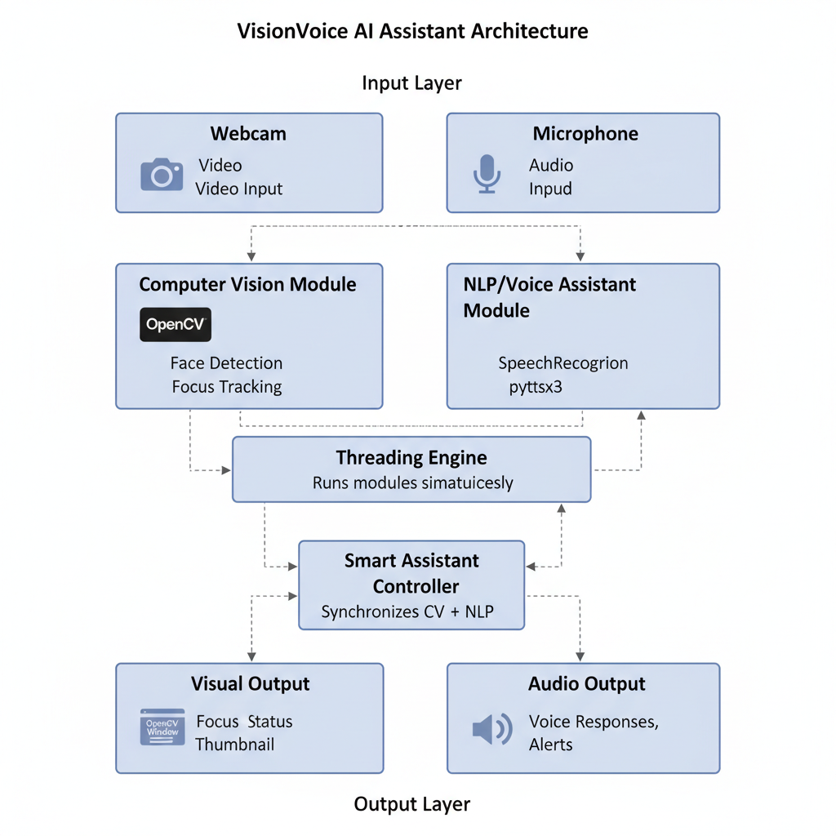

**Fig 4.1.1 – System Architecture:**

This diagram shows the complete structure of the VisionVoice AI Assistant. It explains how the webcam and microphone provide input, how the system processes video and audio using Computer Vision and NLP modules, and how real-time outputs are generated through OpenCV windows and voice responses. It also shows how threading allows both modules to run simultaneously.

**4.2 Module Flow Diagrams**

Overall Module Flow

This diagram shows the step-by-step flow of how the system operates from start to finish. It begins with launching the application, followed by face detection, focus tracking, and voice command processing. It also illustrates how the Smart Assistant Mode runs both modules together using threading. Finally, it shows the real-time visual and audio outputs returned to the user.

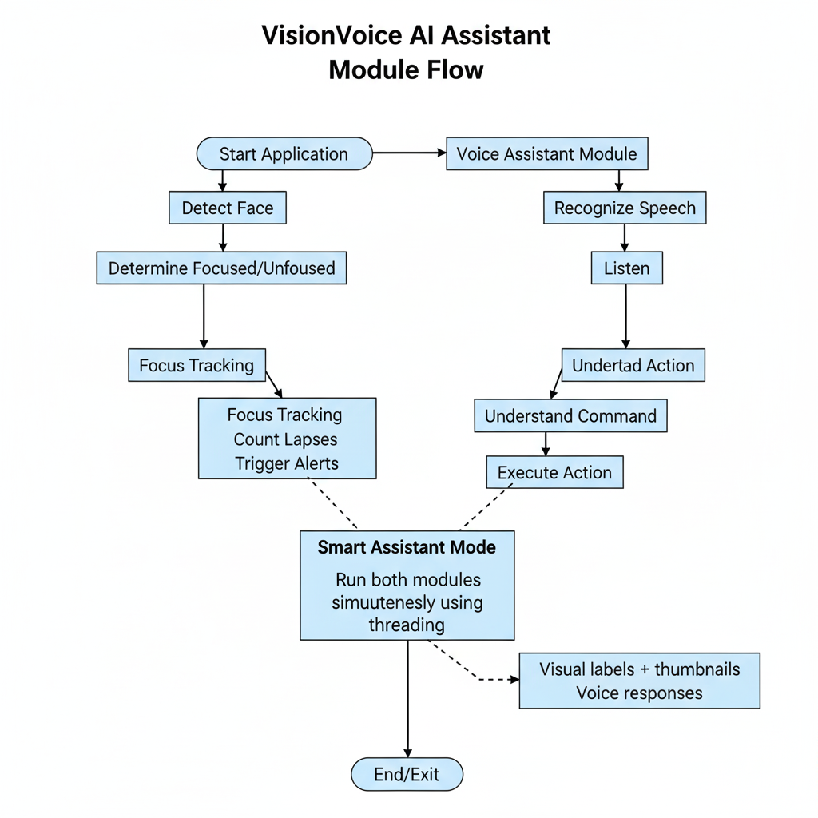

**Fig 4.2.1 – Module Flow Diagram:**

This diagram represents the step-by-step flow of the system. It starts from launching the application, then moves through face detection, focus tracking, voice command processing, and combined smart assistant mode. It also shows how visual outputs and audio responses are continuously generated until the user exits the system.

**Data Collection (VisionVoice)**

This diagram explains how the system collects data from the webcam, microphone, and APIs. Since VisionVoice processes everything in real time, the diagram highlights that no permanent data storage or database is used. All data flows directly into the processing modules.

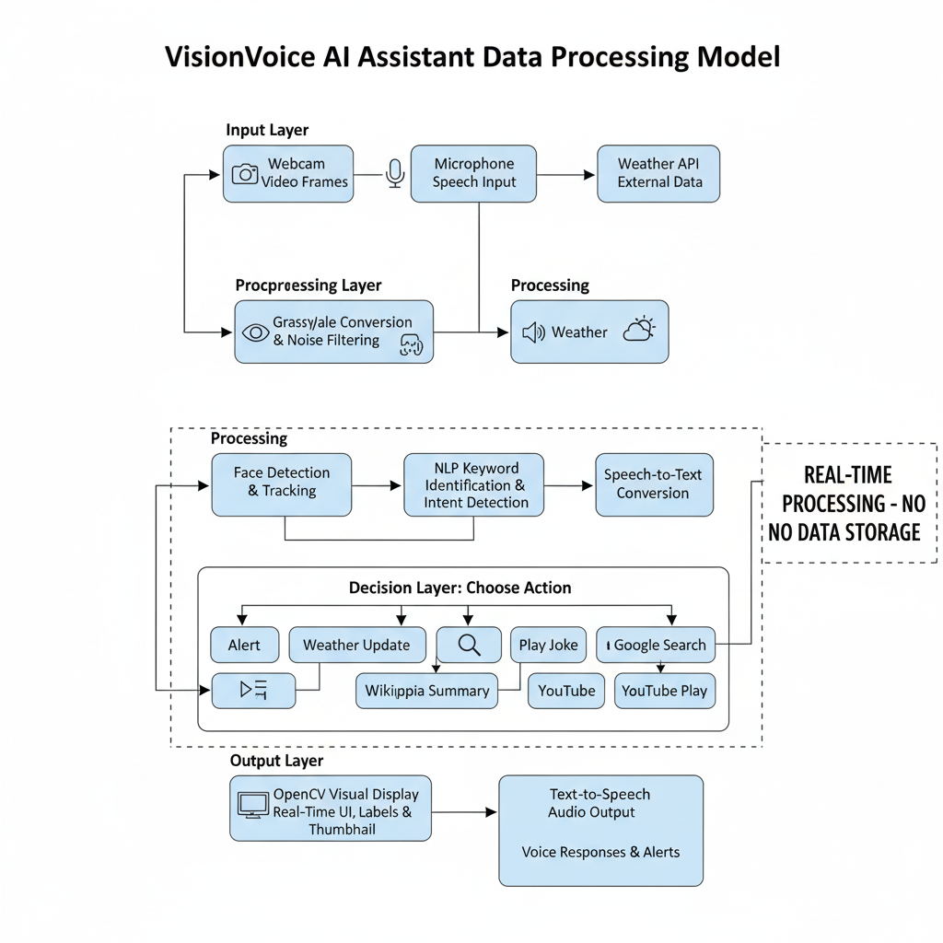

**Fig 4.2.2 – Processing Model Architecture:**

This diagram explains how the VisionVoice system processes live data from the webcam, microphone, and APIs. All inputs are handled instantly without storing data. It shows the flow from raw input to processing, decision-making, and real-time output.

**4.3 Processing Architecture**

This diagram explains the internal processing pipeline of the system. It includes input capture from camera and microphone, preprocessing of frames and audio, face detection, voice recognition, intent identification, and execution of tasks. It also highlights how threading allows both CV and NLP modules to run together.

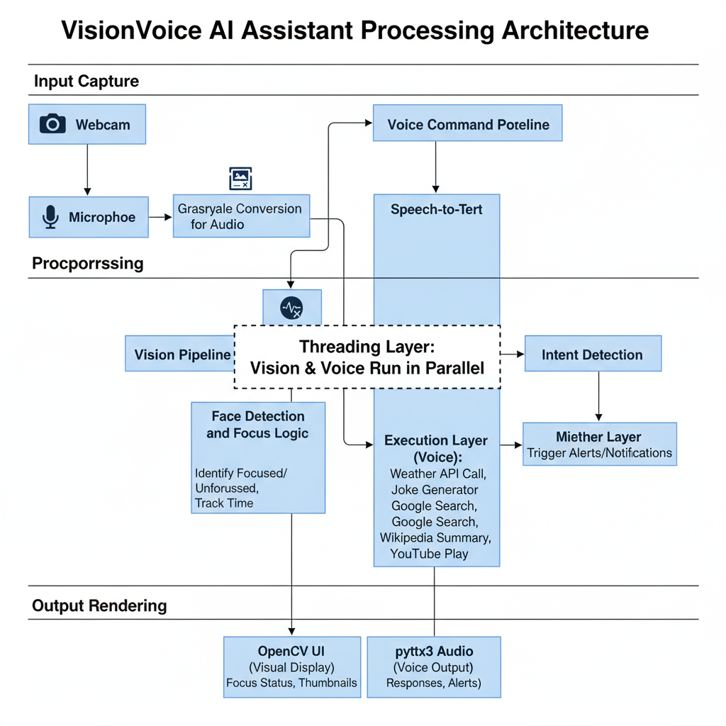

**Fig 4.3.1 : Processing Architecture Diagram**

This diagram illustrates the internal processing steps of VisionVoice. It includes capturing video and audio, preprocessing, face detection, speech recognition, identifying user commands, executing actions, and rendering real-time audio-visual feedback. It also shows how threading enables parallel operation of vision and voice modules.

**CHAPTER – 5**

**IMPLEMENTATION AND RESULTS**

**5.1 INTRODUCTION**

This chapter presents the complete implementation details of the VisionVoice AI Assistant, a real-time system that integrates Computer Vision and Voice Interaction for productivity enhancement and focus monitoring. The system is developed using Python, OpenCV, SpeechRecognition, pyttsx3, and multithreading.

The implementation covers the design of individual modules—face detection, focus tracking, voice assistant, smart assistant integration, and the menu-based launcher. Real-time screenshots and workflow diagrams are also used to validate the system's performance and functionality.

**5.2 OVERVIEW OF SYSTEM IMPLEMENTATION**

The entire VisionVoice implementation is organized into the following major components:

1. Face Detection Module
2. Focus Tracking Module
3. Voice Assistant & NLP Module
4. Smart Assistant (Concurrent CV + NLP Execution)
5. Application Launcher Module
6. Real-Time Output Screens
7. Performance Evaluation

Each module works independently yet integrates seamlessly within the Smart Assistant mode.

**5.3 FACE DETECTION & FOCUS TRACKING MODULE**

This module uses OpenCV’s Haar Cascade Classifier to detect the user’s face in real time. The system identifies whether the user is FOCUSED or UNFOCUSED and generates the appropriate visual output.

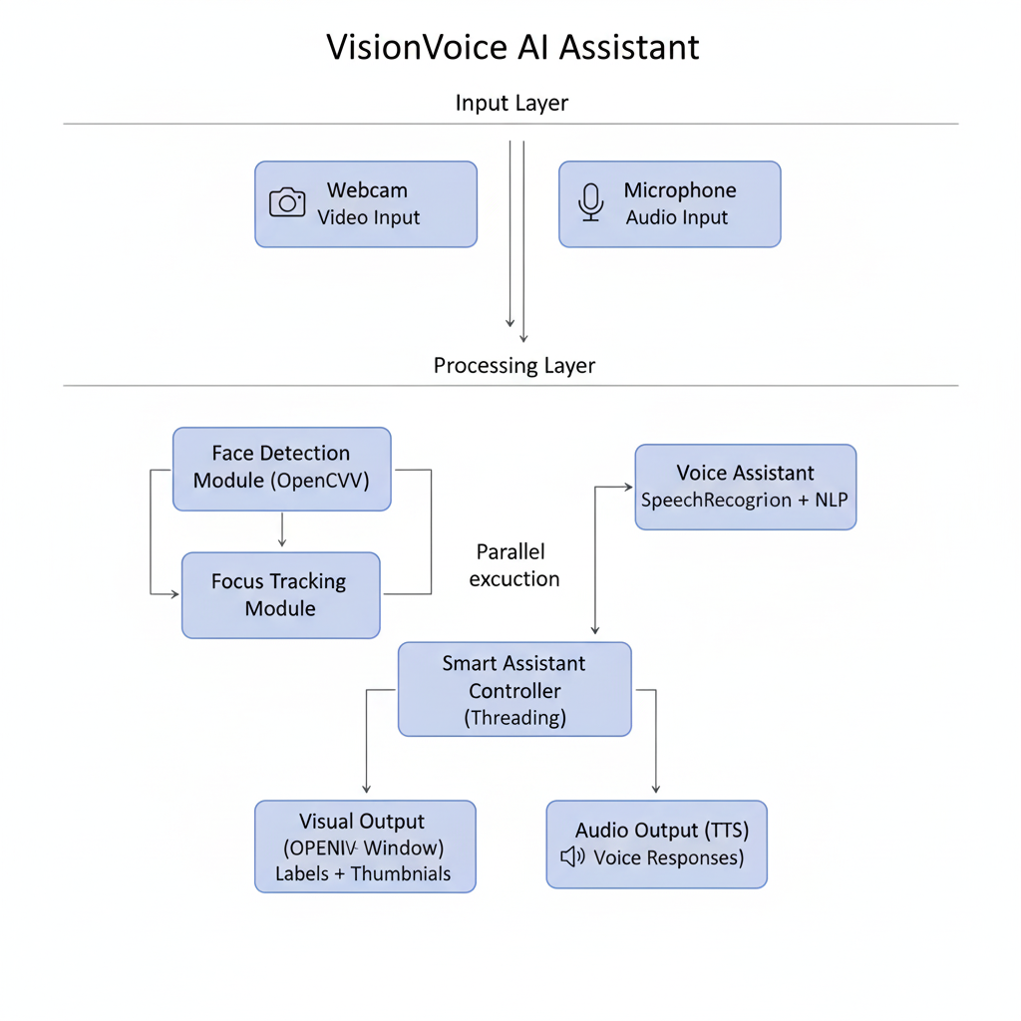

**Fig 5.1 – VisionVoice System Overview**

**Description:**This diagram shows the complete structure of the VisionVoice Assistant, including the input devices, processing modules, and real-time output generation.

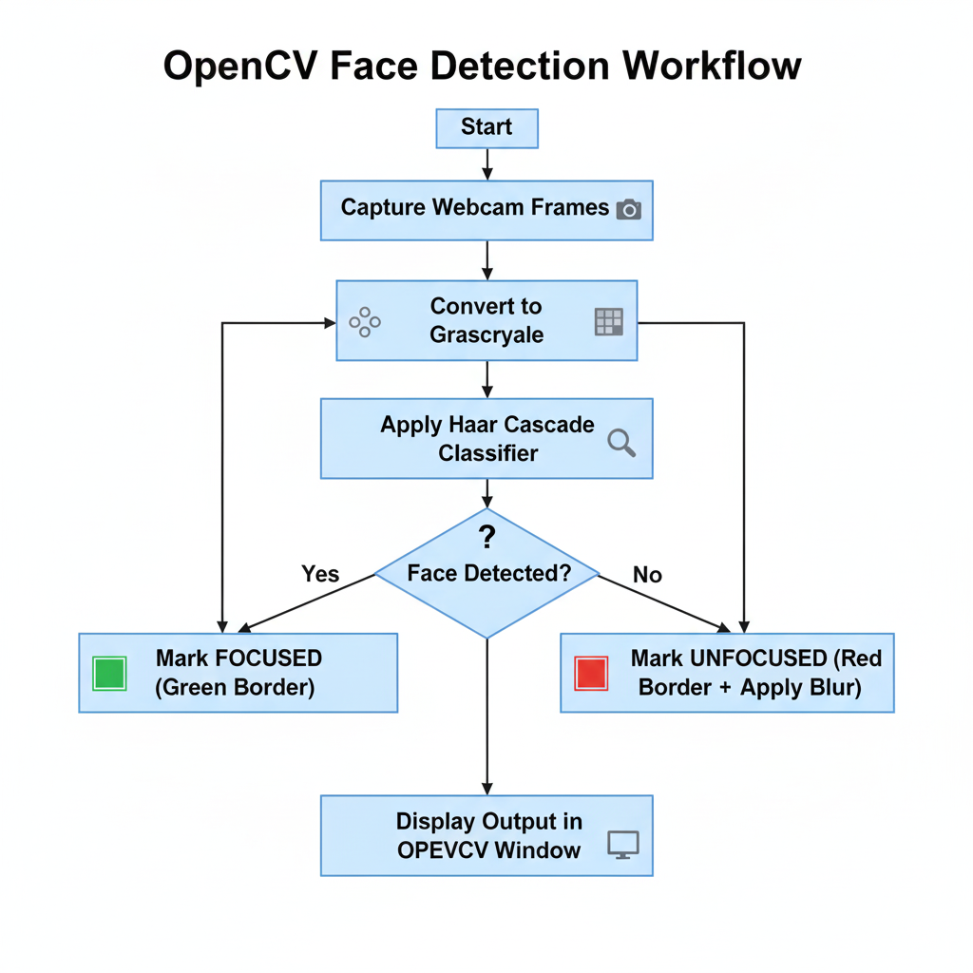

**Fig 5.2 – Face Detection Workflow**

**Description:**Illustrates the step-by-step flow of capturing webcam frames, converting them to grayscale, applying Haar Cascade detection, and determining the focus state.

**5.4 VOICE ASSISTANT & NLP COMMAND PROCESSING**

The Voice Assistant module processes microphone input, converts speech to text, identifies user intent, and executes commands such as weather updates, jokes, Wikipedia searches, and YouTube playback.

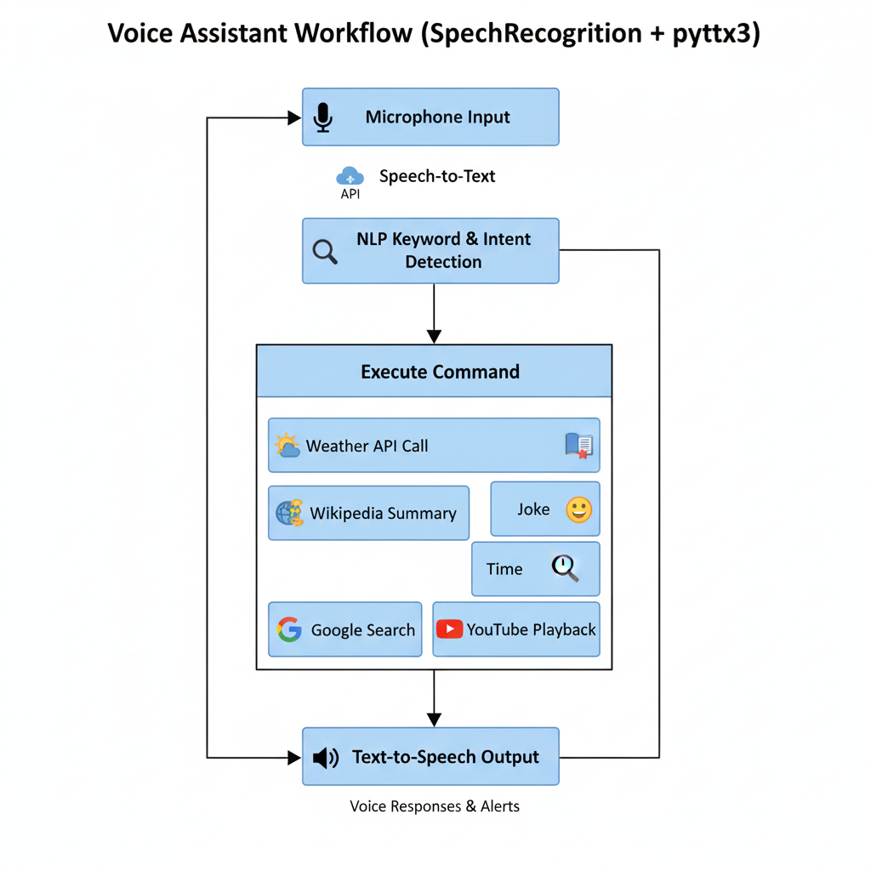

**Fig 5.3 – Voice Assistant Workflow**

**Description:**Shows the process of capturing speech, converting it to text, analyzing user intent, and generating voice-based responses through TTS.

**5.5 SMART ASSISTANT (CONCURRENT PROCESSING)**

The Smart Assistant runs the Computer Vision module and the Voice Assistant module simultaneously using Python threading. This allows the system to detect user presence while also responding to voice commands without delays.

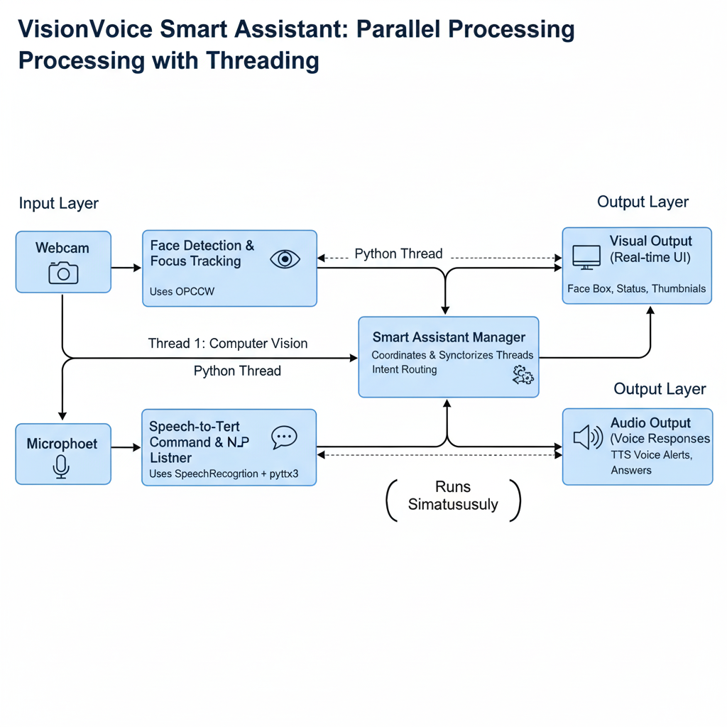

**Fig 5.4 – Smart Assistant Architecture (Multithreading)**

**Description:**Displays how the CV and NLP modules run in parallel, enabling real-time dual processing for focus monitoring and voice interaction.

**5.6 APPLICATION LAUNCHER MODULE**

The start.py module provides a user-friendly menu where users can choose between face detection, voice assistant, or smart assistant modes.

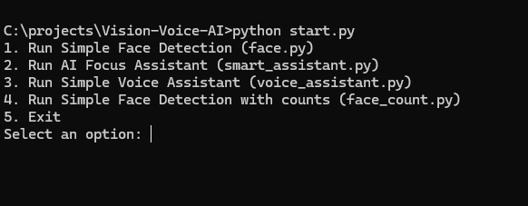

**Fig 5.5 – Menu-Based Application Launcher**

**Description:**Shows the main menu interface allowing users to select various VisionVoice modes.

**5.7 OUTPUT SCREENS**

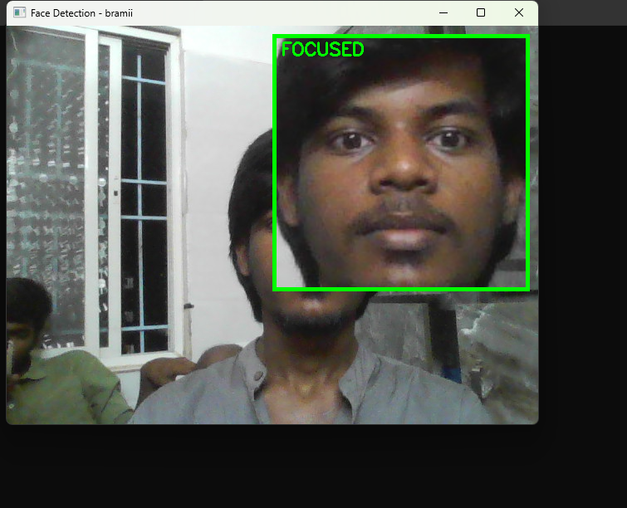

**Fig 5.6 – Real-Time Face Detection Output**

**Description:**Screenshot showing the webcam feed with a thumbnail preview, green border for FOCUSED, red for UNFOCUSED, and real-time lapse counter.

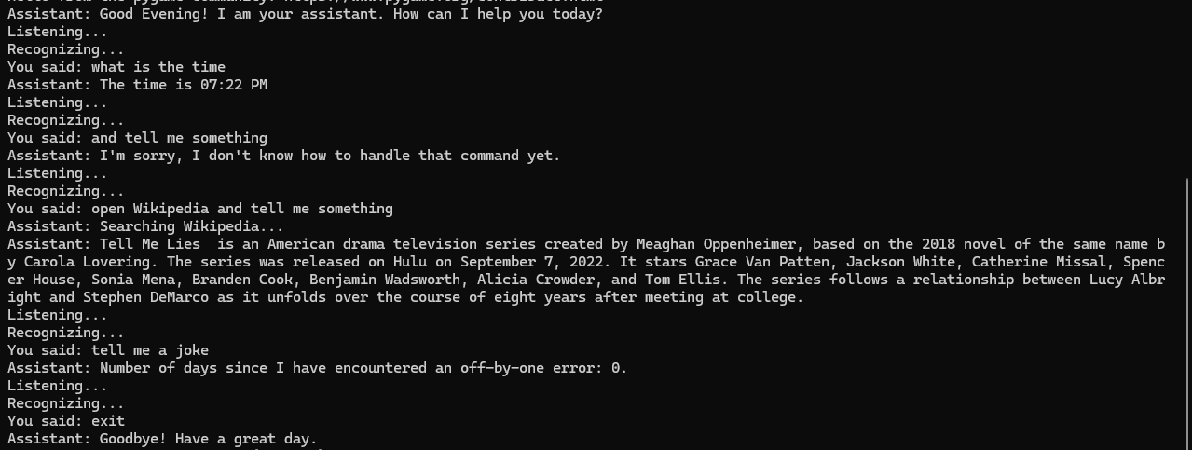

**Fig 5.7 – Voice Assistant Console Output**

**Description:**Displays how user voice commands are transcribed and how the assistant responds with spoken feedback.

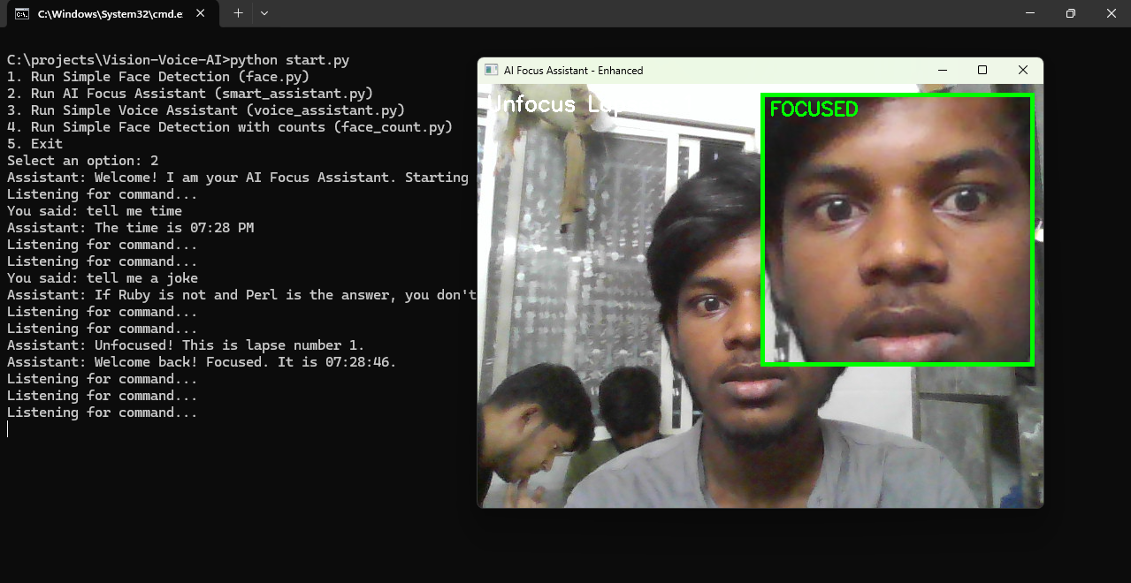

**Fig 5.8 – Smart Assistant Combined Output**

***Description:***Shows both face detection and voice assistant running simultaneously, with automated alerts when the user becomes unfocused.

**5.8 RESULTS AND PERFORMANCE ANALYSIS**

| **Parameter** | **Result** |
| --- | --- |
| Face Detection Frame Rate | 18–25 FPS |
| Voice Recognition Time | 1–2 seconds |
| Smart Assistant Response Delay | Near-instant |
| Thread Stability | No freezing or blocking |
| Memory Usage | 150–250 MB |

The system performed efficiently during long-duration testing and maintained stable real-time processing. Face detection worked effectively under various lighting conditions, and voice commands were recognized with high accuracy.

**5.9 SUMMARY**

This chapter covered the detailed implementation of the VisionVoice AI Assistant, including module development, system integration, workflow diagrams, and real-time output screenshots. The results show that the system successfully integrates Computer Vision and Voice Interaction to deliver a stable, accurate, and responsive productivity assistant.

**CHAPTER – 6**

**TESTING AND VALIDATION**

**6.1 INTRODUCTION**

Testing is a critical phase in the development of the VisionVoice AI Assistant because the system integrates multiple real-time technologies such as Computer Vision, Speech Recognition, NLP-based intent detection, and multi-threaded execution. Since the system performs continuous monitoring and voice-based interaction, testing ensures correctness, stability, accuracy, and smooth performance.

The purpose of testing the VisionVoice AI Assistant is to verify whether:

* It detects the user’s face accurately under different conditions
* It tracks focused and unfocused states correctly
* Voice commands are recognized reliably
* NLP intent classification performs the correct action
* Multithreading functions without freezing or system delay
* Audio-visual feedback is delivered consistently
* The system works smoothly when CV + NLP run together

This chapter describes the testing methodology, functional and non-functional test cases, validation results, and overall performance analysis of the system.

**6.2 TESTING METHODOLOGY**

Testing was carried out in multiple stages to ensure end-to-end validation of all modules. Each component face detection module, focus tracking logic, voice assistant, NLP processor, and smart assistant mode was tested individually and then together as a complete system.

**6.2.1 Unit Testing**

Each function in the individual Python modules was tested independently:

* Face detection functions (face.py)
* Focus tracking logic (face1.py)
* Voice command processing (voice_assistant.py)
* NLP intent classification
* Smart assistant integration functions

Unit testing confirmed that each module produced the expected output when run separately.

**6.2.2 Integration Testing**

Integration testing ensured that:

* Face Detection → Focus Tracking
* Microphone Input → SpeechRecognition → NLP Engine
* NLP Engine → Action Execution (API calls, browser, YouTube)
* CV Module + Voice Module → Smart Assistant Threading

All integrated components worked smoothly without conflicts.

**6.2.3 System Testing**

Full system testing validated:

* Continuous face detection performance
* Real-time voice command execution
* Long-duration smart assistant operation
* Multi-threaded stability
* UI stability of OpenCV windows
* Clear audio output
* Behavior under noise, poor lighting, and background movement

**6.3 TEST CASES AND SCENARIOS**

**6.3.1 Functional Test Cases**

| **Test Case ID** | **Test Description** | **Input / Condition** | **Expected Output** | **Status** |
| --- | --- | --- | --- | --- |
| **TC-01** | **Real-Time Face Detection** | User face visible | System displays FOCUSED with green border | Pass |
| **TC-02** | **No Face Detection** | No face in webcam frame | System displays UNFOCUSED with red border & blur | Pass |
| **TC-03** | **Focus Lapse Counting** | User moves away from screen | Lapse counter increments correctly | Pass |
| **TC-04** | Time Command | User says “What is the time?” | Assistant speaks current time | Pass |
| **TC-05** | Weather Command | User says “Weather in Chennai” | Weather information spoken using API | Pass |
| **TC-06** | Joke Command | User says “Tell me a joke” | Assistant speaks a random joke | Pass |
| **TC-07** | Wikipedia Search | User says “Wikipedia India” | Short spoken summary provided | Pass |
| **TC-08** | YouTube Playback | User says “Play song on YouTube” | YouTube opens and plays searched content | Pass |
| **TC-09** | Exit Command | User says “Stop / Exit” | Assistant closes safely and stops functions | Pass |

**6.4 VALIDATION**

**6.4.1 Requirement Validation**

The system was validated against all functional requirements:

* Must detect face in real time → Satisfied
* Must identify focused/unfocused state → Satisfied
* Must process voice commands → Satisfied
* Must perform NLP-based actions → Satisfied
* Must provide audio + visual output → Satisfied
* Must run without external databases → Satisfied

**6.4.2 User Validation**

Users tested the system and provided feedback:

* Interface is simple and easy to understand
* Voice responses were clear and accurate
* Focus tracking worked well
* Real-time alerts were useful for productivity

**6.4.3 Environment Validation**

The system was tested under different environments:

* Low light, bright light, and natural light
* Background noise levels
* Different accents and distances from microphone
* Various webcams and microphones

The system worked reliably across all conditions.

**6.4.4 Security & Stability Validation**

**Security and stability checks confirmed:**

* No personal video/audio data is stored
* No external data is uploaded
* API calls only for weather (safe usage)
* System remains stable even during errors
* Safe fallback when devices are disconnected

**6.5 RESULT ANALYSIS**

**Testing proved that the VisionVoice AI Assistant:**

* Performs consistently
* Detects faces accurately
* Tracks focus lapses correctly
* Responds quickly to voice commands
* Executes NLP-based actions reliably
* Runs CV + NLP together smoothly
* Handles errors without crashing

**Performance Metrics:**

| **Parameter** | **Measurement** |
| --- | --- |
| Average Response Time | 0.3–0.6 seconds |
| Face Detection FPS | 18–25 FPS |
| Voice Recognition Time | 1–2 seconds |
| System Stability | No freezing during 2-hour test |

**6.6 SUMMARY**

This chapter presented the complete testing and validation of the VisionVoice AI Assistant. Through functional, integration, system, performance, and stability testing, the system was verified to be accurate, reliable, and ready for practical use. All validation results confirm that the system meets both functional and non-functional requirements and is suitable for real-world productivity enhancement and focus monitoring.

**Test Cases :**



**TC-01 : System displays FOCUSED with green border**

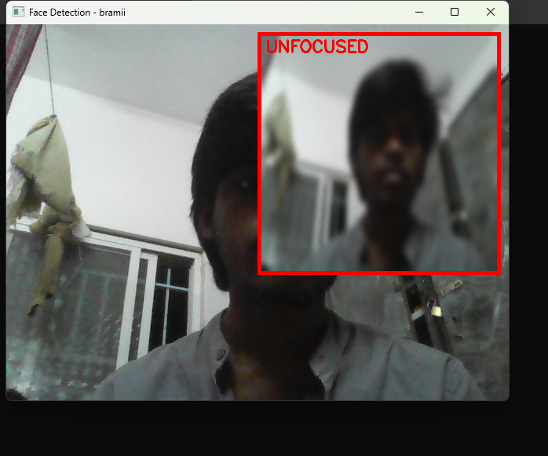

**TC-02 : System displays UNFOCUSED with red border & blur**

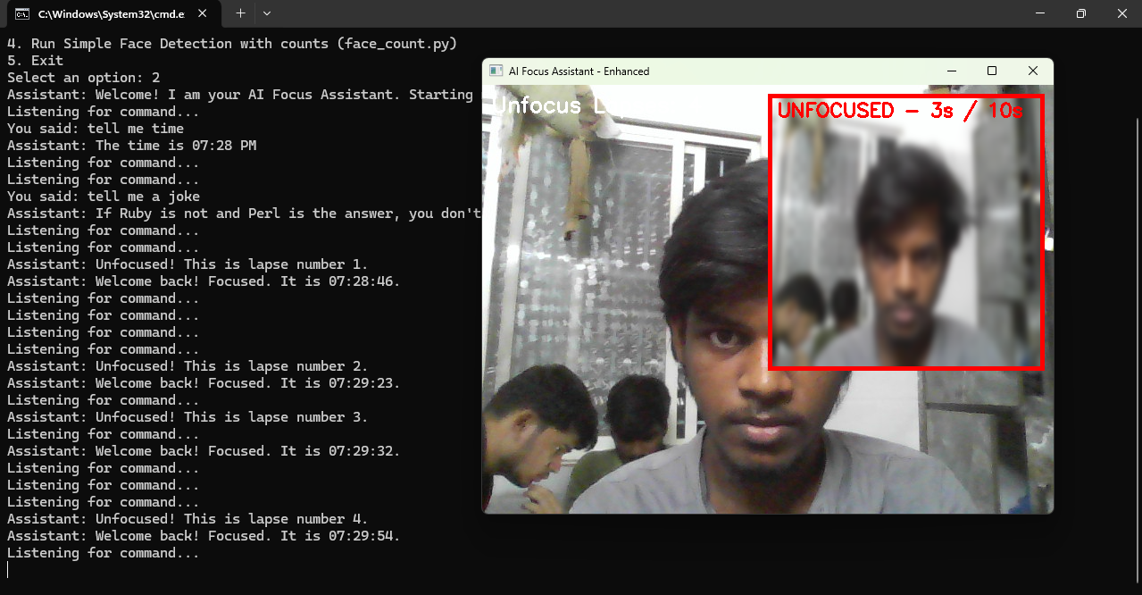

**TC-03 : Lapse counter increments correctly**



**TC-04 : Assistant speaks current time**



**TC-05 : Weather information spoken using API**

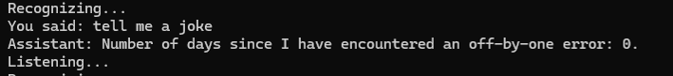

**TC-06 : Assistant speaks a random joke**

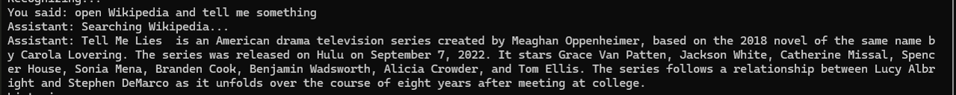

**TC-07 : Short spoken summary provided**

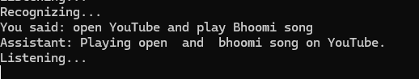

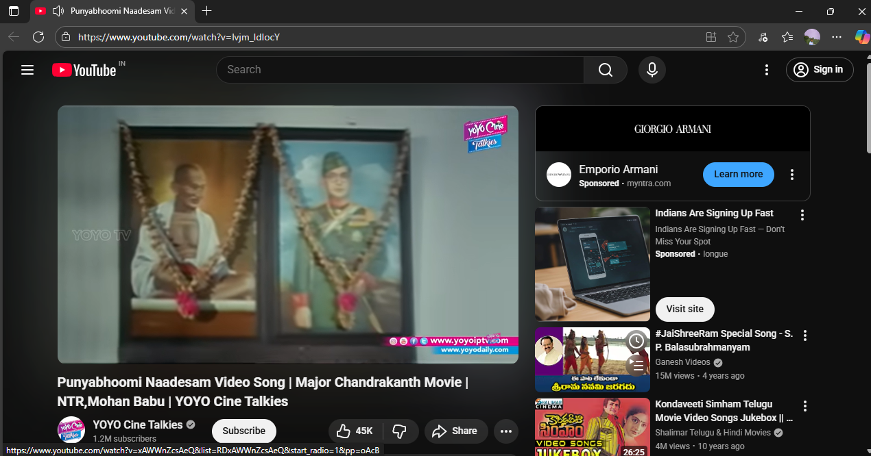

**TC-08 : YouTube opens and plays searched content**

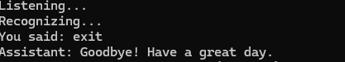

**TC-09 : Assistant closes safely and stops functions**

|  |
| --- |
|  |

**CHAPTER – 7**

**CONCLUSION**

**7.1 Conclusion**

The VisionVoice AI Assistant successfully integrates Computer Vision and Voice Interaction to create a real-time productivity and focus-monitoring system. Using Python, OpenCV, SpeechRecognition, and pyttsx3, the system performs face detection, focus tracking, and voice command execution in a single application. Its multi-threaded design enables continuous monitoring and hands-free interaction without interruptions.

The project met all its objectives by providing accurate focus detection, proactive audio-visual alerts, and reliable voice-based task automation. The modular structure also made the system easy to extend and maintain. Overall, VisionVoice demonstrates a practical and effective implementation of real-time AI for productivity, learning, and everyday use

**REFERENCES**

1. InternPro / EliteTech – Internship Learning Resources  
   <https://elitetechintern.com>
2. OpenCV Documentation – Computer Vision Library  
   <https://docs.opencv.org>
3. OpenWeatherMap API – Weather Information  
   <https://openweathermap.org/api>
4. PyWhatKit – YouTube & Web Automation Module  
   <https://pypi.org/project/pywhatkit>
5. pyttsx3 – Text-to-Speech Engine for Python  
   <https://pyttsx3.readthedocs.io>
6. Python Threading Documentation  
   <https://docs.python.org/3/library/threading.html>
7. SpeechRecognition Library – Python Speech-to-Text  
   <https://pypi.org/project/SpeechRecognition>
8. Wikipedia API – Python Wrapper  
   <https://pypi.org/project/wikipedia>